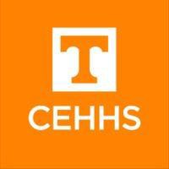
FACULTY MENTOR COUNCIL

Meeting Monday, January 22, 2018
2:00-3:00 pm, Room 412 Claxton AGENDA
- Welcome/Modifications to the Agenda
- Upcoming event: Mentor-Mentee Wine & Cheese Reception, March 7th, 3:00-4:30 pm, Holiday Inn World’s Fair Park

Purpose of the FMC
  - Aim (s), goals, objectives, terms of appointment, structure, expectations from CEHHS administration
  - Work of the FMC
    - Current Tasks: Fall, Pre-Tenure Reception and Spring- Mentor-Mentee Wine & Cheese Reception
  - Page of CEHHS website
  - Relationship to the work of the CEHHS Faculty Senate
    - Invisible labor/service and tenure and mentoring associate professors to move toward full professor

Feedback from Department Heads on Proposed Items for the FMC to work on
  - Hold a panel discussion with the College Promotion & Tenure Committee
  - FMC should meet 1-2 times per year to set and drive and agenda related to mentoring
  - Conduct a survey of junior faculty about their needs related to mentoring
  - Review the literature on mentoring and develop a brief summary for mentors on best practices

Scheduling of Meetings
- Questions/Comments/Concerns

